Stat 216 Spring 2017: Assignment 4
Due Monday, June 20 by 11:00pm
In all calculations, you must show all work to receive full credit! All questions are worth one point unless noted otherwise.

- Which of the following is NOT true about matched pairs design.

- When pairing is effective, differences between pairs tend to be mainly due to the explanatory variables.
- Comparing paired data accounts for some of the variability in the data making it easier to detect differences in the response variable.
- Paired data ideally will give a smaller margin of error than independent groups data.
- When analyzing matched pairs data, it is acceptable to use the independent groups methods.

- Suppose a mathematics education researcher wanted to know if in class activities improved students’ learning compared to traditional lecture only. 28 students were paired with 28 other students with similar GPA, Year in school, and academic major. All were randomly selected from the current MSU student population. One student from each pair was randomly assigned to either the Group Activities with Some Lecture class or the Lecture Only class of M121 (College Algebra). At the end of the semester, students’ final exam scores were recorded and teaching methods were compared.

- What is the response variable? Is it categorical or quantitative?

- What is the explanatory variable? Is it categorical or quantitative?

- Which best describes the study design? Circle one.
- Paired design using matching
- Paired design using repeated measures
- Independent groups

- Explain why you chose the study design above.

- TRUE or FALSE: The sample size for this study is 28 pairs.
- What is the Null Hypothesis, in words, assuming the difference will be calculated activity – lecture.

- What is the Alternative Hypothesis, in notation.

- Calculate the standard error to test for a mean difference in final exam scores between the teaching methods if ${\overline{x}}_{d}= {\overline{x}}_{activity}- {\overline{x}}_{lecture} =10.4, and { S}_{d}=14.5$. (2 points)

- Calculate the standardized test statistic to test for a mean difference in final exam scores between the teaching methods. (2 points)

- Interpret the standardized test statistic you calculated above.
- The standardized test statistic is one standard deviation from the mean of the null distribution.
- The standard deviation of the sample statistic is [your standardized test statistic] from the population standard deviation.
- The sample statistic is [your standardized test statistic] standard errors from the mean of the null distribution.
- The sample statistic is [your standardized test statistic] from the mean of the null distribution.

- The single mean theory based applet calculated a p-value of 0.0018. Interpret this p-value.

- What is your decision based on the p-value above?

- What is the appropriate conclusion, including scope of inference? Circle one.
- Teaching method is associated with a positive difference in mean final exam scores among all MSU students taking M121.
- Teaching method is associated with a positive difference in mean final exam scores MSU students taking M121 who are similar to those in the sample.
- Teaching method caused a positive difference in mean final exam scores among MSU students taking M121 who are similar to those in the sample.
- Teaching method a positive difference in mean final exam scores among all MSU students taking M121.

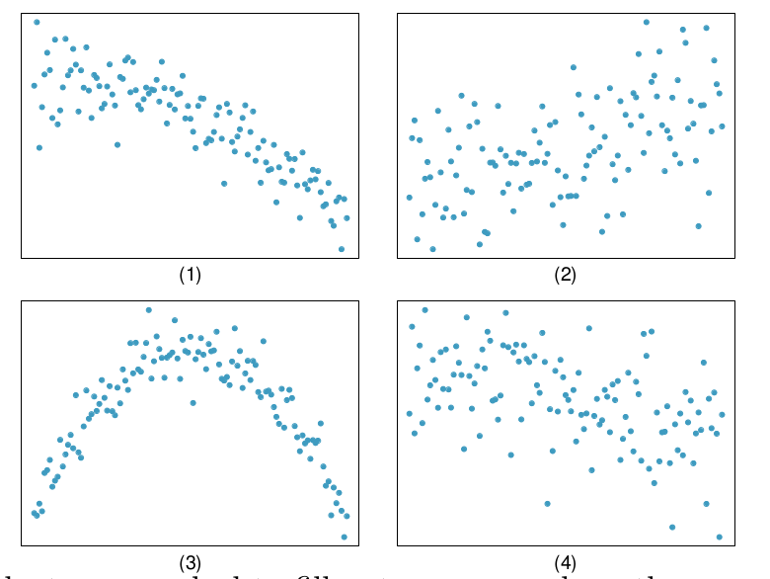
- (2 points) Match each correlation
to the correct plot.

a. r = 0.49

b. r = −0.48

c. r = −0.03

d. r = −0.85

- Which of the following represents the strongest valid correlation coefficient? Circle one.
  - -0.017
  - 0.481
  - 1.23
  - -0.673

- A set of data with two variables is found to have a correlation coefficient of 0.755. Which of the following is probably true about the slope of the estimated regression line for this data?

    - The slope of the estimated regression line is positive
    - The slope of the estimated regression line is negative
    - We cannot infer anything about the slope of the regression line

- we are going to use a data set of highway death rates (per 100 million vehicle miles) and speed limits (in miles per hour) for ten countries. These data come from a time when the United States had a maximum speed limit of 55 miles per hour in all states. An issue of some concern at that time was whether lower speed limits reduce the highway death rate. A scatterplot of the data is below:
`

The equation of the estimated regression line is: $\hat{y}=-0.293+0.076x$

The correlation coefficient for these data is: $r=0.548$

- What are the observational units in this data set?

- (2 points) Write a sentence interpreting the value of the slope in context of this problem.

- Use the regression line equation to predict the highway death rate for a country with speed limit 60 mph.

- Australia had a speed limit of 60 mph and a death rate of 4.9 per 100 million vehicle miles. Calculate the residual for Australia. (Hint: you can use the result from part c above.)

- The following calculations were obtained from the Corr/Regression applet: $SE\left(regression line\right)=5.98$ and $SSE\left(\overline{y}\right)=8.54$ . Use these values to calculate the coefficient of determination.

- Interpret the coefficient of determination from part f in the context of the problem.

- Explain how the y-intercept in the regression line is an example of extrapolation.

- Choose the best descriptor in the brackets:

Britain (with a speed limit of 70 mph and a death rate of only 3.4 per 100 million vehicle miles) is an influential point (labeled observation 4 on the scatterplot). If this observation is removed from the data set, the slope of the regression line will $\left\{\begin{aligned}Increase \\ Decrease\end{aligned}\right\}$ and the correlation coefficient will $\left\{\begin{aligned}Increase \\ Decrease\end{aligned}\right\}$.

- Do these data provide evidence that lower speed limits cause a reduction in the highway death rate? Explain.

